Palliative Single Point of Access
The pSPA is taking an increasing number of general palliative enquiries from patients. This is delaying response to urgent and unplanned advice and support.

Please remind your colleagues to advise patients to use only for
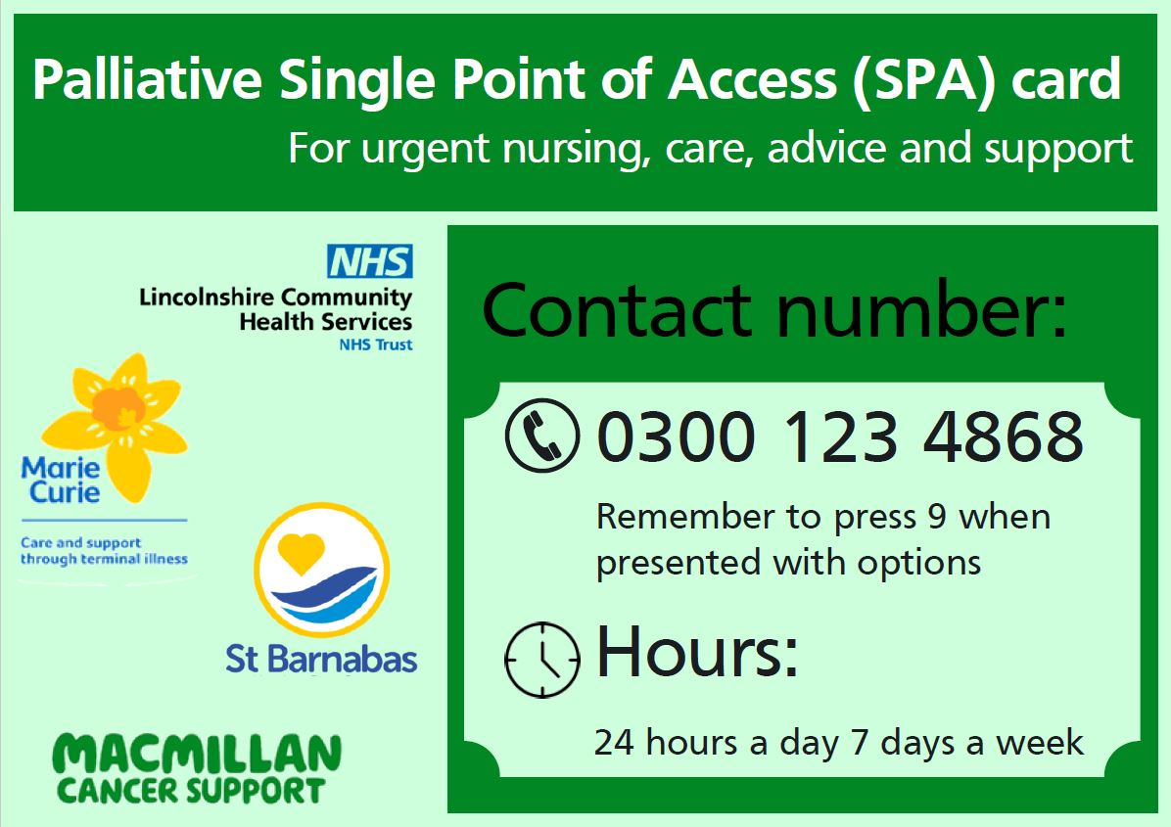
urgent unplanned care, advice, and support.

Proactive palliative assessment and care remains a valued role of the community nurse teams.

General communication between the patient and the community nurse team should continue via the usual way.

The green card does not replace this.

Please also remind Care Home providers in your area – a growing number are using the pSPA to request planned patient reviews.

pSPA – a single number to simplify patient access to urgent help and advice.
What it is not - replacing planned assessment, general communication intended for community nurse teams, eg: request to drop off supplies, chat about considering a catheter

