

CODE OF CONDUCT - DECLARATION OF INTERESTS

Name: _______Robert Severn________________________________________________________

1. | Remunerated Directorship of company(s) (public or private and businesses owned personally or in partnership | NA
2. | Remunerated employment or Offices | The Company Chemist Association  Rowlands Pharmacy  Community Pharmacy Nottinghamshire
3. | Remunerated Consultancy(s) | Carpmaels & Ransford LLP
4. | Remunerated work performed under contract | NA
5. | Names of companies or other bodies in which I have an interest, either on my own account, my spouse or infant children, for a beneficial interest in share holdings greater than 10% of the capital share | NA
6. | Remunerated contributions to professional and scientific publications | NA
7. | Other sources of income or pecuniary support relevant to my membership of the LPC | NA
8. | Membership of other pharmaceutical bodies | GPhC  RPS  Community Pharmacy Nottinghamshire


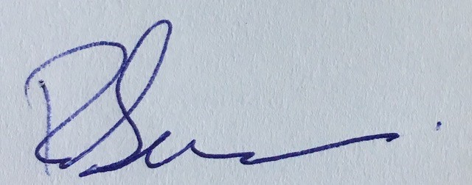
Signed: ____________________________ Date: ________14.11.2024_________________

