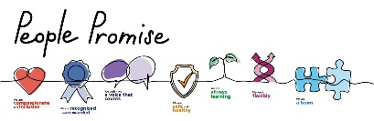
Lincolnshire Primary Care Saying Thank You Campaign

Lincolnshire Primary Care staff work hard in often challenging circumstances to provide you with the care and treatment you need. Simply saying thank you really can make a world of difference. If you would like to leave a message of thanks to a member of staff, please compete the form below.
This Saying Thank You Campaign will run until the end of March 2025. At the end of the campaign, we will be rewarding the practice with the highest number of messages of thanks (adjusted for patient population) with a prize.

Name of the practice or pharmacy you attended:

Date of appointment/visit:

N

Name of the member of staff you would like to thank

Role of the staff member (if known)

Y

Your message of thanks

