**Using the AccuRx suite (Accumail) to refer a patient to pharmacy**

**KIV: the system does not provide any triage facility so users will need access to appropriate training and aide-memoires (aide-memoires are available from** [**stuart.hellon@pharmacylincolnshire.org**](mailto:stuart.hellon@pharmacylincolnshire.org) **)**



1. Click on the @ symbol on your toolbar shown above

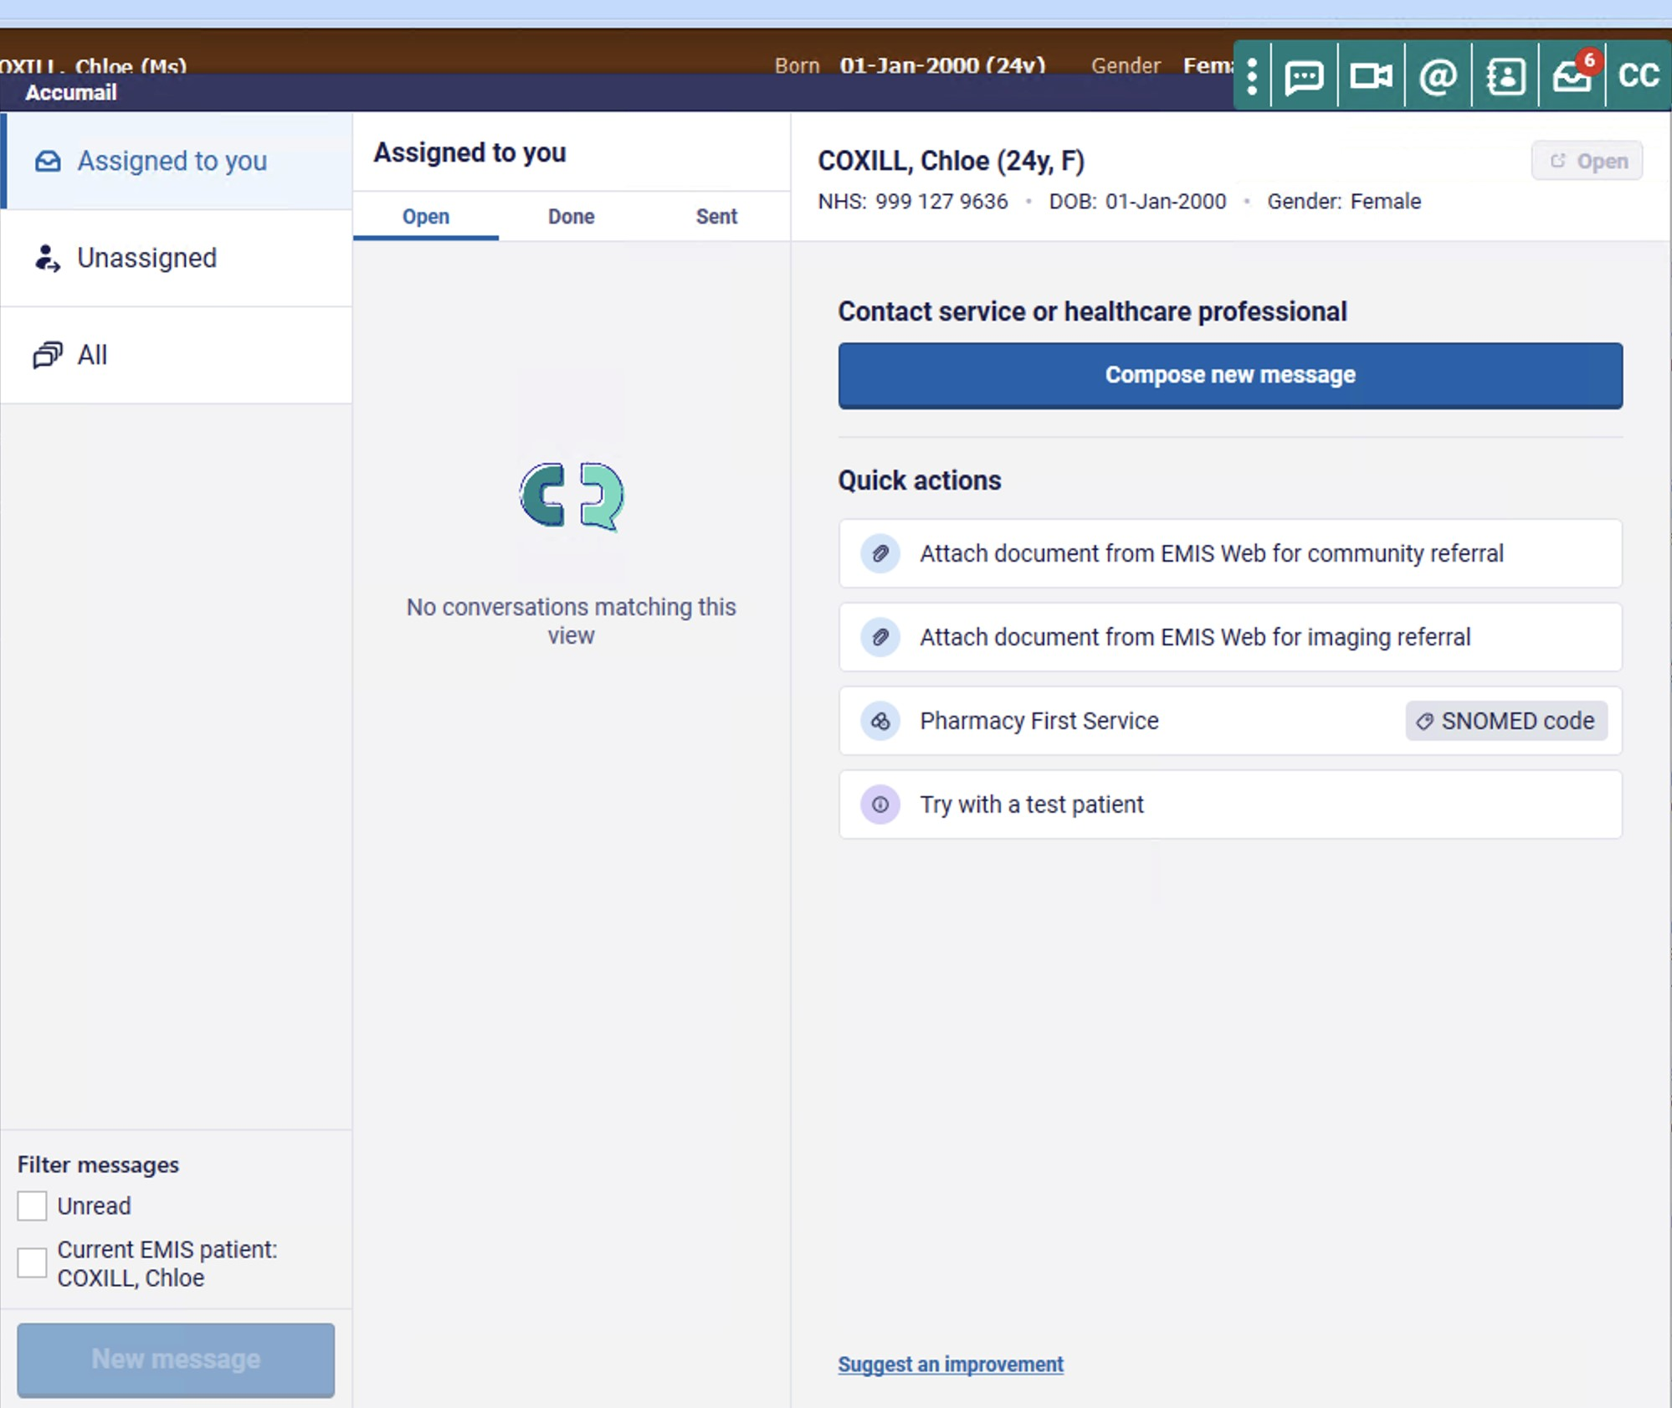

1. This will bring up your Accumail inbox as shown above. Then click on Pharmacy First Service

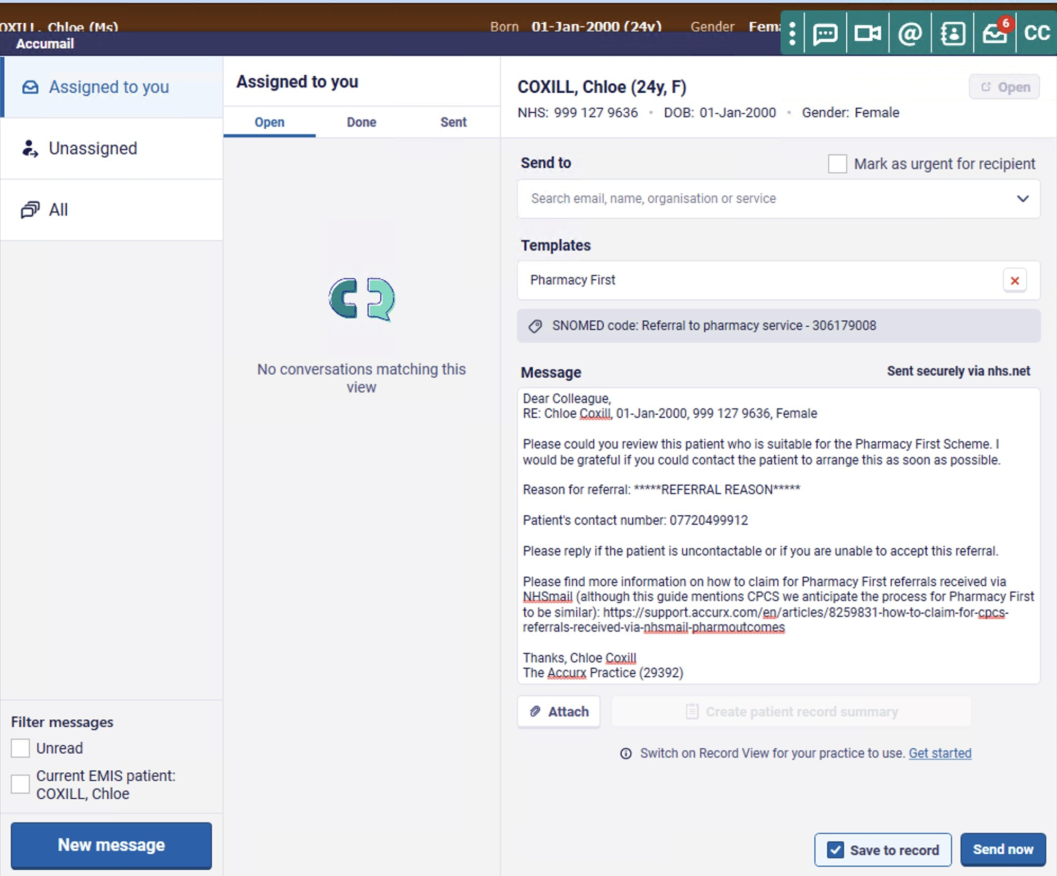

1. The Accumail inbox will pull the details of the patient currently open in SystmOne, so have the patient you would like to refer into pharmacy open in the background. From the compose message screen in Accumail, you will only be able to see your most recent and most contacted email addresses. You can view more details about a contact by hovering over the contact and then selecting "See details". If you can't find your contact in the recent list, you can try to search for the contact using the search and a wider list of organisations will be shown. If you need a wider view of emails please select "View all contacts" at the bottom of the list. You will then be taken to the Desktop toolbar directory where you can search for contacts more clearly

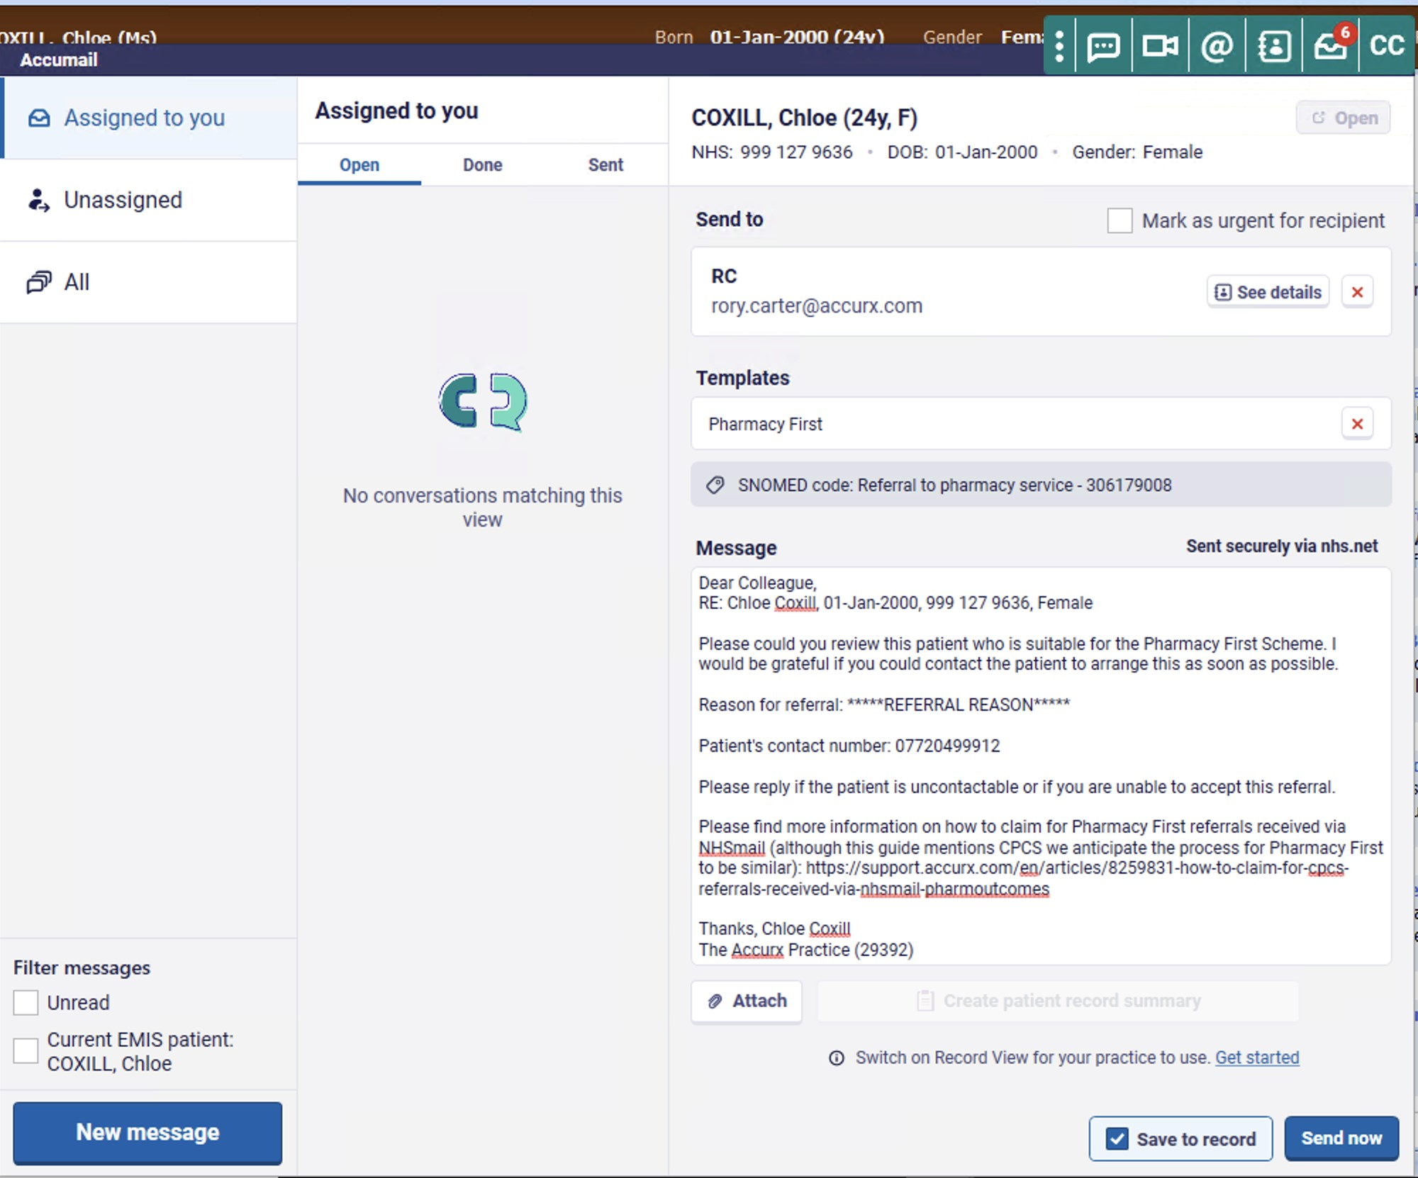

1. It will automatically have pulled the Pharmacy First template into the Message section, which you can see above. You can edit this message if you would like to change it. Ensure that you overwrite the referral reason into the referral reason section: “*****REFERRAL REASON*****”
2. Click “Save to record” to save into the patient record then “Send now” to send to the Pharmacy