


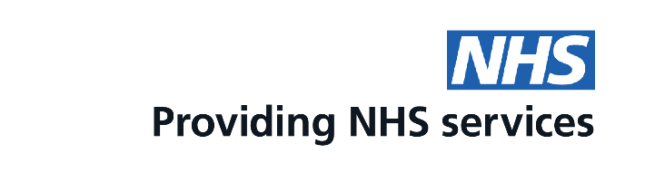
Time for your pill check?
You can now get your pill check, oral contraception and emergency contraception at a community pharmacy

Scan the QR code to find a participating pharmacy
This is a free service funded by NHS England

