


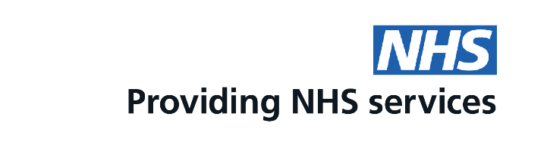
Worried you left it late?
You can now get advice and a supply of oral contraception or emergency contraception from some community pharmacies

Scan the QR code to find a participating pharmacy
This is a free service funded by NHS England

