

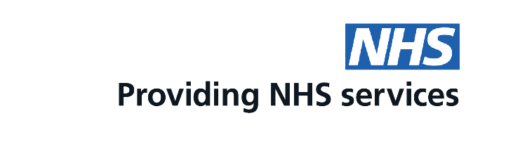
Too busy to wait for an appointment for a pill check?
You can now get your pill check, oral contraception and emergency contraception at this pharmacy

Ask us today for more information
This is a free service funded by NHS England

