
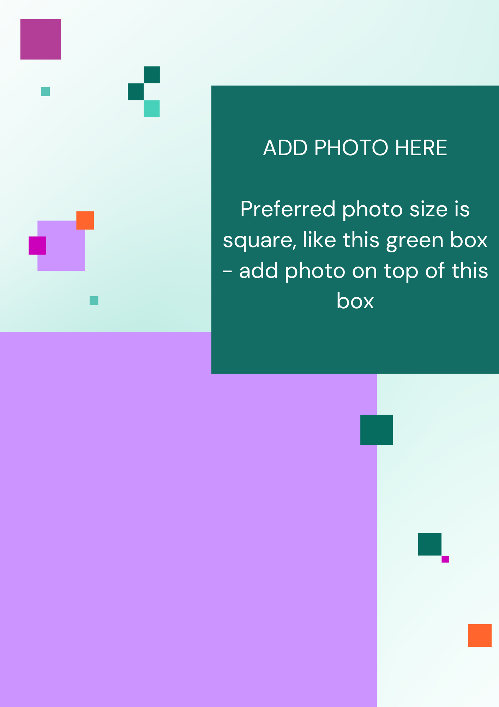
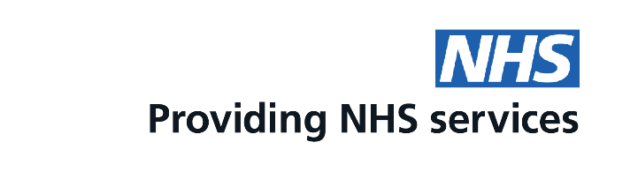
Need advice about emergency contraception or the pill?
Did you know your pharmacy can help you with that?
Ask us today for more information
This is a free service funded by NHS England

