Treatment of Gender incongruence/Gender dysphoria
The information below provides a summary of the key recommendations around treatment of gender incongruence/dysphoria in primary care. Recommendations for both general practice and community pharmacy are found in section 1 and 2 respectively.
- NHS England is the responsible commissioner for Gender services.
- UK legislation restricts the prescribing and supply of puberty suppressing hormones (PSH) in children and young people (CYP) under 18 for treating gender incongruence or dysphoria due to insufficient evidence and medicine safety concerns, particularly regarding compromising bone density. See the NHS England Clinical Policy: Puberty suppressing hormones (PSH) for children and young people who have gender incongruence/ gender dysphoria [1927] March 2024.
- See the Royal College of General Practitioners GP position statement, March 2025, The role of GPs in transgender care

Section 1 - Recommendations for general practice
- March 2026 NHSE guidance to primary care advises GPs against agreeing shared care agreements with unregulated providers who supply hormone medications to children and young people with gender incongruence.
- Assessment and treatment recommendations must be made by a gender identity clinic (GIC)/ gender dysphoria clinic (GDC) specialist in the context of a diagnosis of gender incongruence of adolescence and adulthood defined by ICD-11 HA60 or gender incongruence of childhood defined by ICD-11 HA61.
- Prescribing and monitoring plans for adults should be established through shared care agreements following Gender Identity Clinic/Gender dysphoria clinic (GIC/GDC) specialist assessment
- Review any patients prescribed masculinising/feminising hormone therapy outside of NHS protocols. In older adolescents these may be continued by the GIC/GDC (jointly with the related endocrine clinic), if preset criteria are met.
- Be aware that Sustanon® injection is the only licensed product for gender dysphoria ‘as a supportive therapy for female-to-male transsexuals. Other treatments are unlicensed or off-label but may be prescribed if clinically necessary to meet the specific needs of the patient and where there is no suitably licensed medicine that will meet the patient’s need. Inform patients of the unlicensed use.
- Prescribers should ensure that community pharmacists are provided with sufficient information to safely dispense private or NHS prescriptions for GnRH analogues or other hormones for gender dysphoria.
- Prescribers considering supporting adult patients with bridging prescriptions for hormone treatments should ensure that all the following conditions are met before prescribing:
- Someone is self-medicating hormones or seems highly likely to self-medicate from an unregulated source (over the internet or otherwise on the black market)
- The bridging prescription is intended to mitigate a risk of self-harm or suicide
- The doctor has sought specialist advice and prescribes the lowest acceptable dose in the circumstances

Section 2 - Recommendations for community pharmacy
- Prescribers should ensure that community pharmacists are provided with sufficient information to safely dispense private or NHS prescriptions for GnRH analogues or other hormones for gender dysphoria.
- Community pharmacists should be aware of the restrictions on dispensing NHS and private (UK and non-UK) prescriptions for GnRH analogues and other hormones for gender dysphoria and be able to explain these to prescribers and patients.
- Review the ‘Quick reference guide puberty blockers (GnRH analogues) dispensing restrictions’ in appendix 1 below to understand the restrictions on supply of these medications in full.

Appendix 1 - Quick reference guide puberty blockers (GnRH analogues) dispensing restrictions

In June 2024, the UK Government introduced emergency restrictions on the prescribing and supply of puberty blockers (gonadotropin-releasing hormone (GnRH) analogues) when used as puberty-suppressing treatment for gender dysphoria/incongruence in children and adolescents under 18 years. These restrictions were introduced following safety concerns highlighted by the Cass Review and the Commission on Human Medicines.¹⁻³

This applies to all puberty-suppressing (GnRH analogues) including:
- Buserelin⁴
- Gonadorelin⁵
- Goserelin⁶
- Leuprorelin acetate⁷
- Nafarelin⁸
- Triptorelin⁹

Restrictions
- New patients under 18 years cannot start puberty blockers for gender dysphoria/incongruence outside designated NHS specialist services.
- This applies to all private prescribers, including those based overseas.
- Community pharmacies must not dispense puberty blockers for gender dysphoria/incongruence if prescribed privately by a non-UK prescriber (EEA/Swiss prescriber).

Do not dispense if:
- The patient is under 18 years AND
- The prescription is for gender dysphoria/gender incongruence AND
- The prescriber is not UK-registered i.e. EEA prescribers, Swiss prescribers, or any overseas private clinic
- The patient has been newly initiated on a puberty blocker after 4th June 2024
- The patient is continuing a puberty blocker and the prescription is not endorsed ‘ SLS’ (specialist list scheme)

Can dispense for:
- Licensed indications for non-gender dysphoria/incongruence indications (e.g. precocious puberty, certain cancers)
- Continuing under-18 years on puberty blockers for gender dysphoria only if the:
- Prescriber is UK-registered (GMC doctors)
- Prescription is endorsed “SLS”
- Patient was already established on treatment before June 2024 restrictions

Table 1 below summarises the puberty suppressant restrictions post-June 2024 as a checklist with actions needed and whether the prescription can be dispensed in the UK.
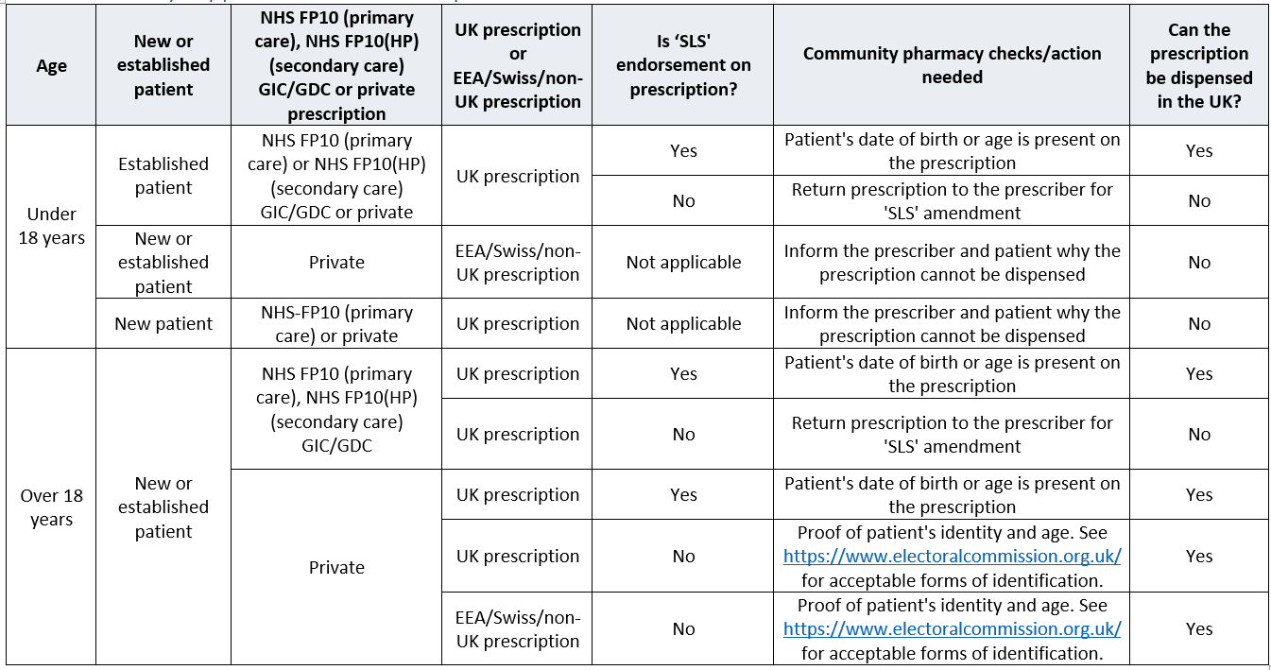

References

- Cass H. The Cass Review. April 2024. https://cass.independent-review.uk/wp-content/uploads/2024/04/CassReview_Final.pdf
- NHS England. Clinical Policy: Puberty suppressing hormones (PSH) for children and young people who have gender incongruence / gender dysphoria [1927]. March 2024. https://www.england.nhs.uk/wp-content/uploads/2024/03/clinical-commissioning-policy-gender-affirming-hormones-v2.pdf
- Department of Health and Social Care. Consultation outcome. Proposed changes to the availability of puberty blockers. Updated October 2025. https://www.gov.uk/government/consultations/proposed-changes-to-the-availability-of-puberty-blockers-for-under-18s/proposed-changes-to-the-availability-of-puberty-blockers#the-impact-of-the-emergency-order
- Summary of Product Characteristics. Suprefact 1 mg/ml injection solution for injection. Neon Healthcare Ltd. Date of revision of text 17/06/25. https://www.medicines.org.uk/emc/product/11242/smpc
- Summary of Product Characteristics. Gonapeptyl Depot 3.75 mg Powder and solvent for suspension for injection. Ferring Pharmaceuticals Limited. Date of revision of text 02/12/24. https://www.medicines.org.uk/emc/product/2229/smpc
- Summary of Product Characteristics. Zoladex 3.6mg Implant. AstraZeneca UK Limited. Date of revision of text 27/03/24. https://www.medicines.org.uk/emc/product/1543/smpc
- Summary of Product Characteristics. Prostap 3 DCS 11.25 mg Powder and Solvent for Prolonged-release Suspension for Injection in Prefilled Syringe. Takeda UK Ltd. Date of revision of text 12/06/25. https://www.medicines.org.uk/emc/product/4651/smpc
- Summary of Product Characteristics. Synarel 2mg/ml Nasal Spray. Pfizer Limited. Date of revision of text 08/22. https://www.medicines.org.uk/emc/product/1149/smpc
- Summary of Product Characteristics. Decapeptyl SR 11.25mg (triptorelin pamoate). Ipsen Ltd. Date of revision of text 07/11/24. https://www.medicines.org.uk/emc/product/780/smpc

